# Task 1 Part 1

Realistic Version

Photo: This Is taken from Google Earth

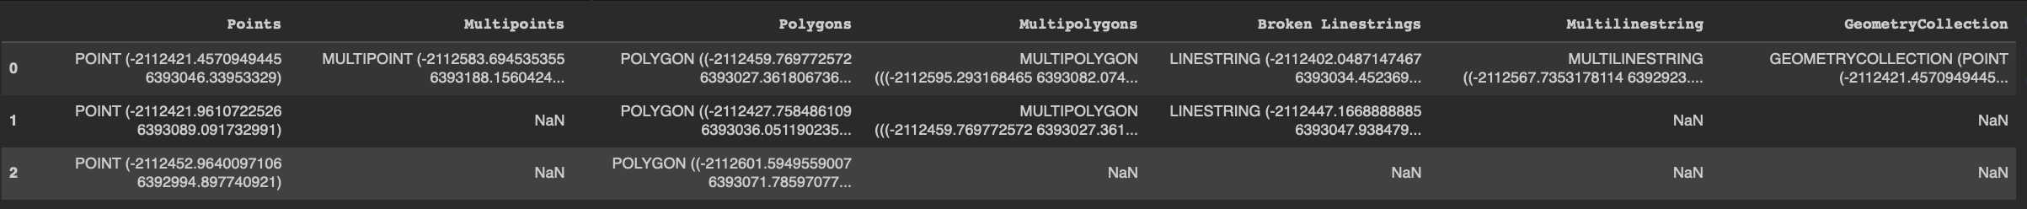  
  
More Simple version  
